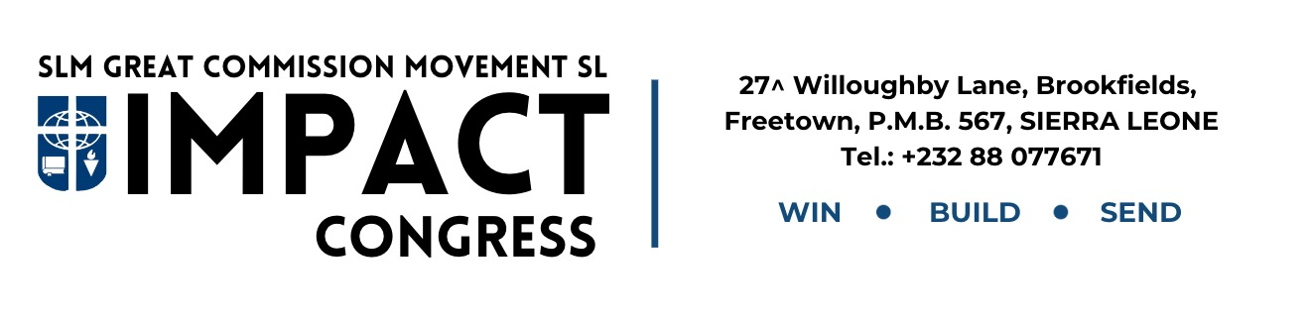

Dear Sir/Madam,

**Request For Permission To Attend IMPACT Congress 2025**

I am writing to respectfully request your permission for your child/ward to attend the upcoming IMPACT Congress 2025, organized by the Student Led Movement – Great Commission Movement Sierra Leone (GCMSL).

The Congress is scheduled for 14th to 21st September 2025 at the Mount Zion Training Center, Mothaim, Regent, Freetown. This national event brings together students and professionals from across the country for a week of leadership development, personal growth, and spiritual enrichment, under the theme: “Living and Telling” (Acts 1:1).

We believe that this Congress will be a life-changing experience, equipping participants with valuable skills and deeper insight for effective service and leadership. We kindly ask that you grant your child permission to be part of this significant event. We are confident that their involvement will yield long-term benefits, both personally and academically. Thank you for your attention and kind consideration. We look forward to a positive response.

Yours faithfully,

Esther Nyajay Lebbie

+23278536322

Secretary.